Innovative Integration: Shaping Disaster Nursing for Planetary Health and Risk Reduction

Ai Yamada^1, Aarav Bhandari^2, Emily Johnson^3
^1 School of Health Sciences, Kobe Institute of Nursing, Japan
^2 Centre for Public Health, University of Nepal, Kathmandu, Nepal
^3 Department of Emergency Management, California University, Berkeley, USA

Session Overview:
This workshop will delve into the dynamic role of disaster nursing in the broader context of planetary health. It aims to forge a synergy between localized approaches and universal health standards to enhance global disaster risk reduction efforts.
Methodology:
The workshop will engage participants through interactive methodologies including simulations, case study analyses, and group discussions based on global surveys, interviews with disaster nurses, and research findings from Japan, the UK, and the USA. These activities are designed to foster collaborative learning and cultivate actionable strategies for community engagement and resilience.
Panelists/Presenters:
Ai Yamada, an expert in global health and disaster nursing; Aarav Bhandari, a public health initiative specialist; and Emily Johnson, an emergency management authority, will guide the workshop. They bring diverse experiences and knowledge in disaster nursing, crucial for the development of adaptive strategies in health crises.
Expected Audience:
Healthcare professionals and emergency responders interested in enhancing their knowledge and skills in disaster nursing are encouraged to attend. The workshop will offer insights into integrating disaster nursing within cross-disciplinary frameworks to promote community resilience.
Coordination with the Organizing Committee:
We are open to collaboration with the committee to refine the workshop details and will communicate our specific needs for successful delivery. Panelist/Presenters/

Please submit this completed document to the conference secretariat. You will be contacted for coordination and to discuss any further necessary adjustments or requirements. We are dedicated to assisting you in delivering a successful and memorable session.
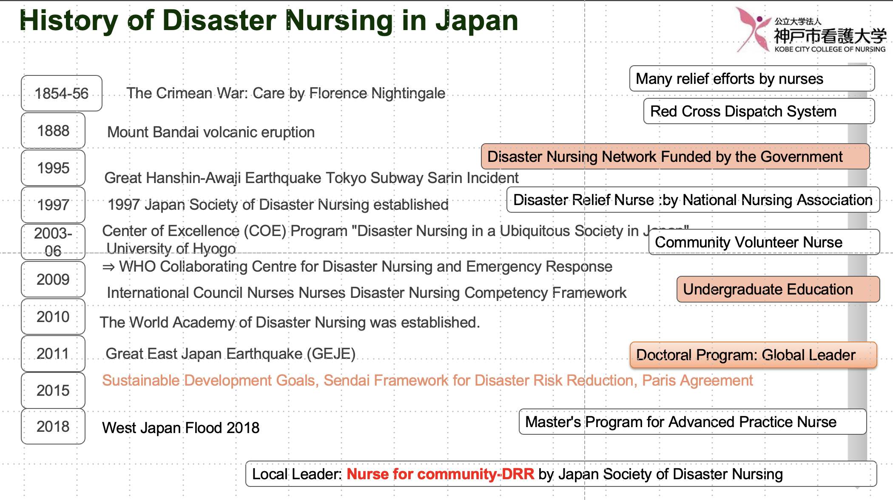 (Your photo, and any Figure also available)
Contact Information:
Email : info@wsdn2024.com
FaceBook: https://www.facebook.com/profile.php?id=61555182692934
_______________________________________________________________________
Note: Remember to ensure that the details provided are as comprehensive as possible to facilitate the planning process. The bios and photos should present the panelists in a professional light, emphasizing their qualifications and relevance to the session's topic.

